Marketing Cloud Login IP says that all Salesforce IP’s are automatically included
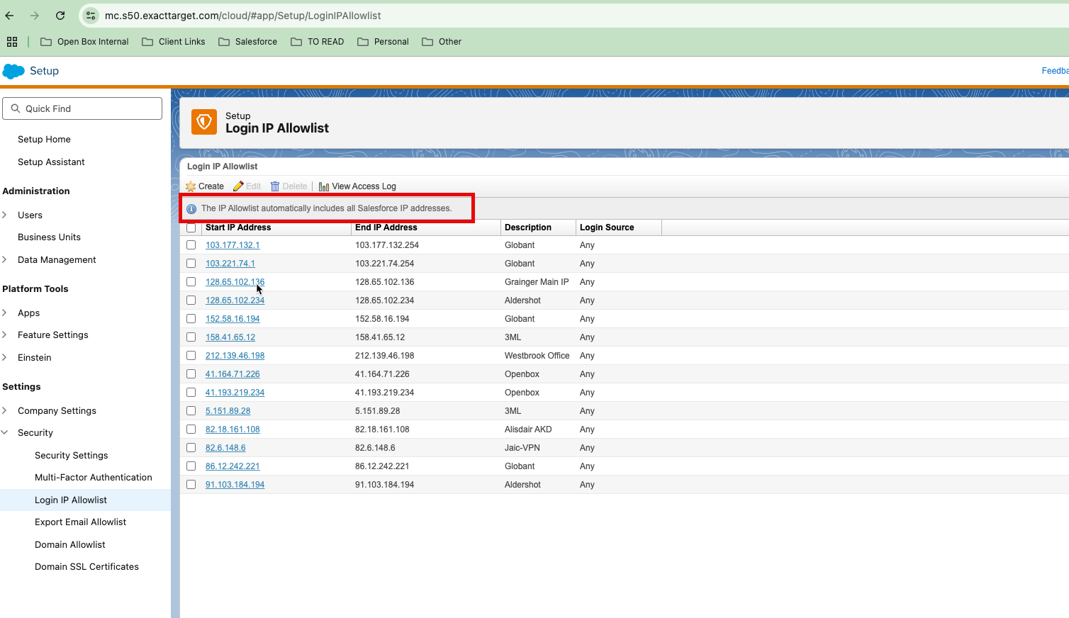

But I get the error below when using Apex to connect to the Marketing Cloud API (https://mcdklx9xmtlvpnb0b44zmzr9yhbm.auth.marketingcloudapis.com/)

17:25:30:651 USER_DEBUG [50]|DEBUG|Exception during callout: Unable to fetch the OAuth token. Error: invalid_grant. Error description: The client's IP address is unauthorized for this account. Allowlist the client's IP address in Marketing Cloud Administration..

When I check Marketing Cloud logs, I see that IP 145.224.201.254 has been denied as per screenshot below.
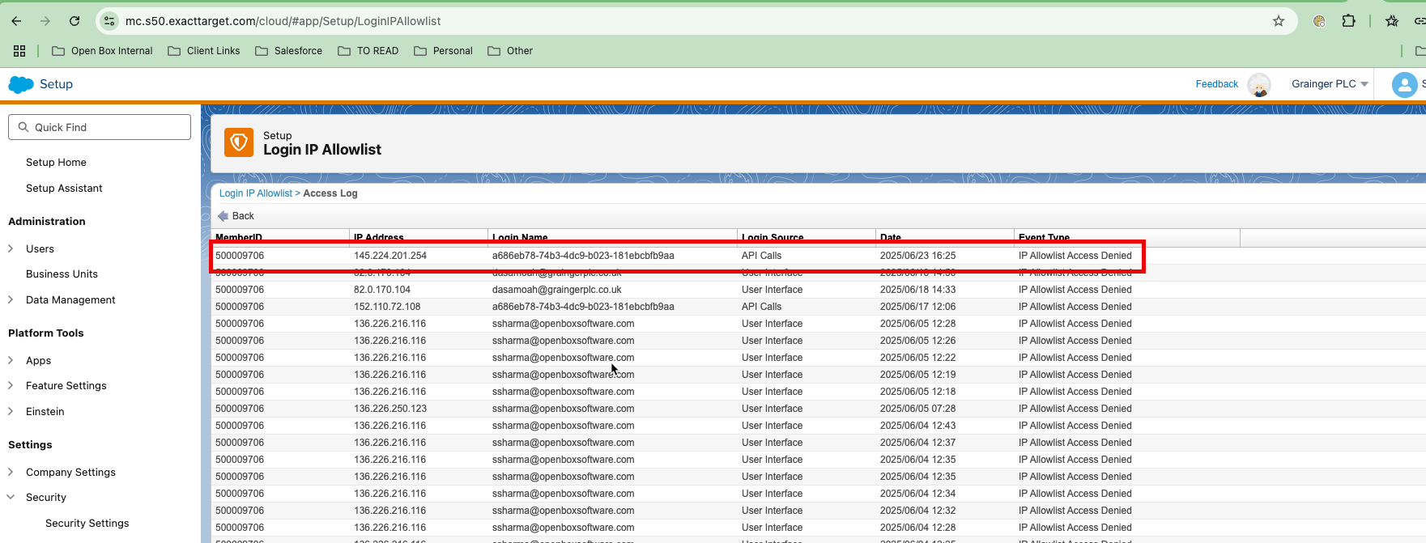

This IP belongs to Salesforce as far as I can see (see screenshot below).

https://mxtoolbox.com/SuperTool.aspx?action=arin%3a145.224.201.254&run=toolpage
